- Vectors 2
1. In the figure below E is the mid point of BC. AD:DC = 3:2 and F is the meeting point of BD and AE
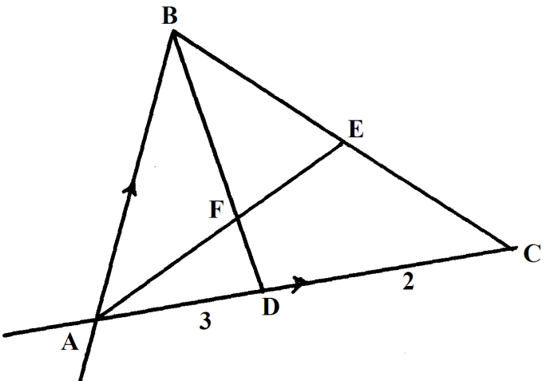
If AB = and AC =
(a) Express the following in terms of and
(i) 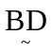 (1mk)
(ii) 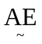 (2mks)
(b) If 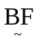 = t and 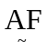= n find the value of t and n. (5mks)
(c) State the ratio of BD to BF. (1mk)
2. In the figure below OA = a and OB = b. Points P and T divide 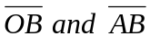 internally in the ration 2:3 and 1:3 respectively. Lines 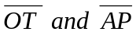 meet at Q.
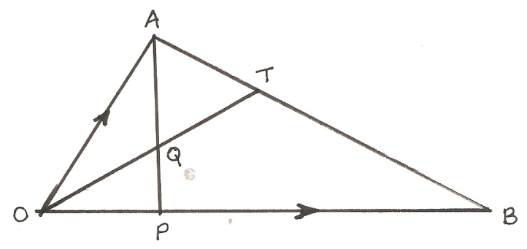
Find in terms of 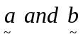
(i) 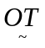 (3mks)
(ii) 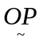 (1mk)
(iii) 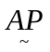 (1mk)
(iv) 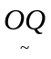 (5mks)
If OQ = kOT and AQ = hAP where k and h are constants express OQ in two different ways and hence find the values of h and k. (10mks)

3. In the figure below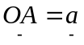, 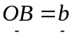and DB is parallel to OA. C is on AB extended such that AB: BC = 2:1 and that OA = 3DB.
A
O
B
D
C

- Express the vector BC in terms of a and b. (1mk)
- Show by vector methods that the points O, D and C are collinear. (3mks)
4. In the figure below 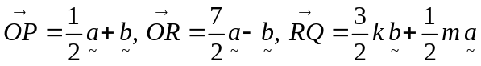, where k and m are scalars 2PS = 3SR.
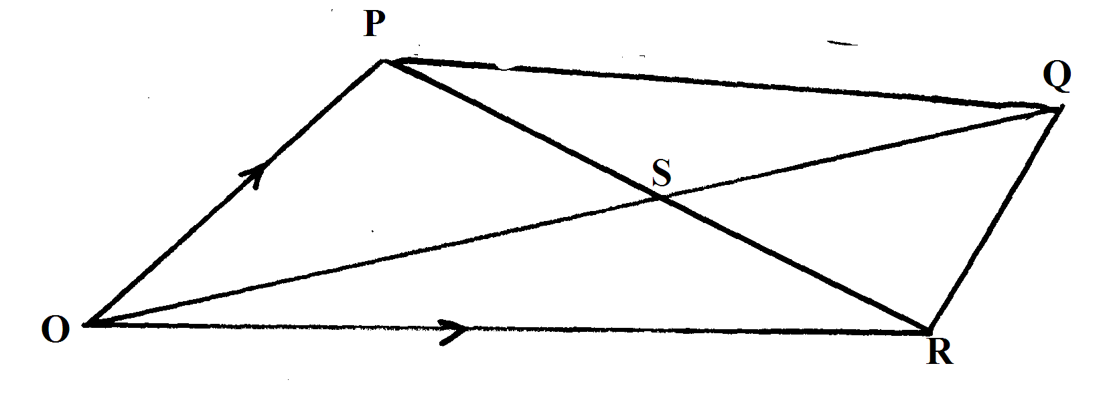
(a) Express as simply as possible in terms of 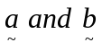each of the following vectors.
(i) 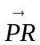 (1mk)
(ii) 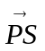 (1mk)
(iii) 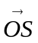 (1mk)
(b) Express 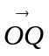in terms of a, b, k and m. (2mks)
(c) If Q lies on produced with ; = 5:4, find the value of k and m. (5mks)
5. In the figure below, DE = ½ AB and BC = 2/3 BD and the co ordinates of A,B and D are (5,4),(9,6) and ( 12,0) respectively.
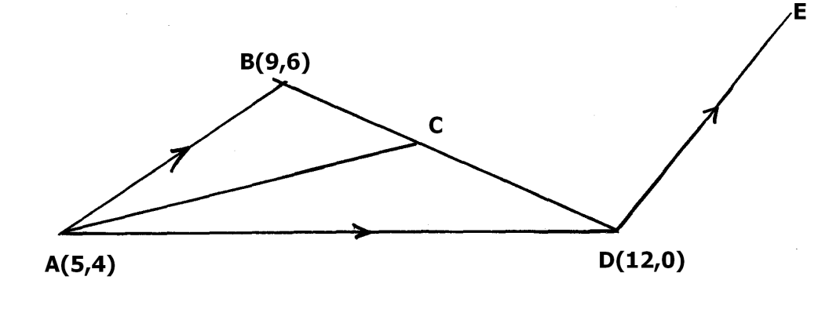
Find the vectors
(i) BD (1mk)
(ii) BC (1mk)
(iii) CD (1mk)
(iv) AC (2mks)
b) Given that AC = kCE; where k is a scalar,
Find
(i) the value of k (4mks)
(ii) the ratio in which C divide AE. (1mk)

6.
A
In the figure alongside OA = a , OB = b. T lies on AN such that
~
~
AN : TN = 13:6. M lies on AB such that AM:MB=1:3 and
M
~
~
N lies on OB such that OB:BN = 7:-5.
~
~
B
a
T
~
(a) Express in terms of a and b in the simplest form
(i) AN
~
~
O
B
(ii) AT
N
~
b
(iii) AM (b) Show that O, T and M are collinear and state the ratio of OT: TM

7. A point (-3, 4) divides AB internally in the ratio 3:5. Find the coordinates of point A
given that point B is (6, -5)

8. Given that O is the origin, OA = 3i + 2j – 4k and OB = 6i + 11j + 2k. If x divides AB
~
~
~
~
~
~
~
in the ratio1:2, find the modulus of OX to 2d.p
~

9. a) Expand (2 – ¹/₅x)⁵
b) Hence use the expansion to find the value of (1.96)⁵ correct to 3 decimal places

10. In the figure OABC is a trapezium in which 3 AB = 2OC. S divides OC in the ratio 2:1
~
and AS produced meets BC produced at T
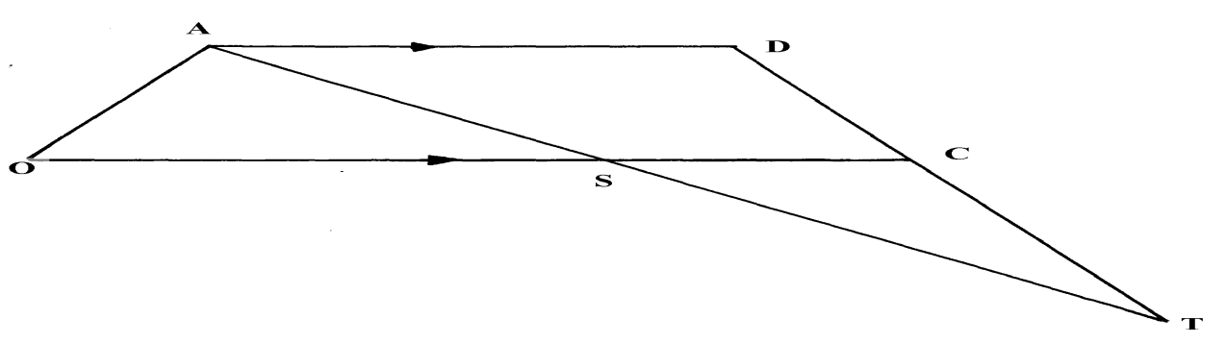
B

Given that OC = 3c and OA = a
(a) Express AS and BC in terms of a and c
~
~
(b) Given further that AT = hAS and BT = KBC where h and k are constants
(i) Express AT in two ways in terms a, c , h and k
~
~
~
~
~
(c) The obtuse angle between the lines PQ
O
Q
R
T
S
P
(d) Hence find the ratio BT: BC
~
~

11.

In the figure above, OPQ is a triangle in which OS = ¾ OP and PR: RQ = 2 : 1. Lines OR and SQ meet at T.
(a) Given that OP = P and OQ = q, express the following vectors in term of p and q





(i) PQ

(ii) OR

(iii) SQ

(b) You area further given that ST = m SQ and OT = n OR. Determine the values of m and n





